Payroll Calculation Inheritance
PayrollCalculation implements IPayrollCalculation
This is the starting point and has a lot of the functions, such as
AddPayItems
AddRetirementItems
AddTaxItems
GetBasisAmount
GetBasisYTDAmount
Calculation implements ITaxCalculation

SystemCalculation

SystemAnnualCalculation

FITCalculation

FIT2020Calculation

SITCalculation

SIT2018Calculation
System YTD Calculation

SystemFUTACalculation

SystemMDCCalculation

SystemSDICalculation

SystemSSCalculation

SystemSUICalculation

To add the code that handles the 2018 SIT ID exemption modification, in changeset 17993 on 5/29/18, I added an overrideable property called TaxTypeTaxExemptions to Calculation. In Calculation, TaxTypeTaxExemptions returns Me.Item.TaxExemptions which is the employee’s tax type exemptions value.
I patterned TaxTypeTaxExemptions after the existing SystemCalculation property called TaxTypeStatus which turns the employee’s tax type marital status into a value called TaxTypeStatus. This property had a note about being reworked to eliminate an infinite loop which, I think, is why it looks as funky as it does. (Not sure what I meant by that. Perhaps I meant it uses an “original” value.)
The TaxTypeTaxExemptions property had to be at the Calculation level because Calculation has a protected function called CalculateExemptionAmount which requires the number of exemptions. This function isn’t overridden by any of the descendants. This function loops through the exemptions (i.e. FOR i = 1 TO number of exemptions), adding the amount for each exemption. It gets the amount from a list of exemption amounts that has been built for the FIT or for the state.
In the case of SIT, Calculation has been instantiated as an SIT2018Calculation (i.e., is of type SIT2018Calculation) which is inherited from SITCalculation.
I overrode the TaxTypeTaxExemptions property on SITCalculation. In SITCalculation, the property calls an overrideable function called GetTaxTypeTaxExemptions passing it the state. On SITCalculation the function GetTaxTypeTaxExemptions returns 9999 (instead of returning Nothing because I was having trouble declaring the returned value as Short? (which means a short that is nullable)).

Calculation Implements ITaxCalculation
Protected Overridable Function CalculateAnnualTaxableWages() As Decimal
Protected Function CalculateExemptionAmount() As Decimal
Protected Function CalculateIncomeTax(taxableWages As Decimal) As Decimal
SystemCalculation
SystemCalculation has Properties which hold the TaxType table information. These properties are the only thing in SystemCalculation.
Public Overrides ReadOnly Property TaxTypeCalendar As Models.TaxTypeCalendarModel

Public ReadOnly Property HasMultipleTaxTypeCalendars As Boolean

Public Overrides ReadOnly Property TaxTypeCalendarStatus
As Models.TaxTypeCalendarStatusModel

Public Overrides ReadOnly Property TaxTypeCalendarStatusCredits
As IList(Of Models.TaxTypeCalendarStatusCreditModel)

Public Overrides ReadOnly Property TaxTypeCalendarStatusExemptions
As IList(Of Models.TaxTypeCalendarStatusExemptionModel)

Public Overrides ReadOnly Property TaxTypeCalendarStatusRates
As IList(Of Models.TaxTypeCalendarStatusRateModel)

Public Overridable ReadOnly Property TaxTypeStatus As String
Returns MaritalStatus

SystemAnnualCalculation
Private _taxTypeCalendarSupplementalTaxPercents As IList(Of Models.TaxTypeCalendarSupplementalTaxPercentModel)

Public ReadOnly Property TaxTypeCalendarSupplementalTaxPercents As IList(Of Models.TaxTypeCalendarSupplementalTaxPercentModel)
Public Overrides Sub Calculate()

If Me.Item.IsSupplementalTax AndAlso
decSupplementalTaxPercent > 0D Then
decIncomeTax = Me.CalculateSupplementalIncomeTax(decSupplementalTaxPercent)
Else
Dim decAnnualTaxableWages = Me.CalculateAnnualTaxableWages()
decIncomeTax = Me.CalculateIncomeTax(decAnnualTaxableWages)
End If

Protected Overridable Function CalculateSupplementalIncomeTax(supplementalTaxPercent As Decimal)

Protected Function GetAmount(incomeTax As Decimal)

FIT Calculation
Property NonresidentAlienAdditionalTaxableWages
Function CalculateAnnualTaxableWages()
Dim decAnnualTaxableWages = MyBase.CalculateAnnualTaxableWages()
Custom code related to annual taxable wages for FIT
Function CalculateSupplementalIncomeTax(supplementalTaxPercent As Decimal)
Has the logic to calculate the FIT supplemental tax

Calculation Implements ITaxCalculation
Protected Overridable Function CalculateAnnualTaxableWages() As Decimal
Dim taxableWages = New TaxableWages

taxableWages.AnnualGrossWages = Me.Item.AnnualGrossWages

'Calculate Standard Decuction Amount

If Me.TaxTypeCalendarStatus.StandardPercent > 0D Then
taxableWages.StandardDeductionAmount = taxableWages.AnnualGrossWages * (Me.TaxTypeCalendarStatus.StandardPercent / 100D)
If Me.TaxTypeCalendarStatus.MaximumAmount > 0D AndAlso
taxableWages.StandardDeductionAmount > Me.TaxTypeCalendarStatus.MaximumAmount Then
taxableWages.StandardDeductionAmount = Me.TaxTypeCalendarStatus.MaximumAmount
End If
Else
taxableWages.StandardDeductionAmount = Me.TaxTypeCalendarStatus.MaximumAmount
End If

'Calculate Exemption Amount

taxableWages.ExemptionAmount = Me.CalculateExemptionAmount()

'Calculate the Federal Tax Deduction Amount

taxableWages.FederalTaxDeductionAmount = Me.PayrollCalcuation.GetCurrentAmount("TAX", "FIT", EM.Entities.Headers.TaxTypeHeader.GetPayer("FIT"), Me.Item.CheckSequence) * Me.Item.PayFrequency * Me.TaxTypeCalendarStatus.FederalMultiplier

If Me.Item.IsState Then
Me.CalculateAnnualTaxableWagesStateExceptions(taxableWages)
End If

Dim decTaxableWages As Decimal = 0D

If taxableWages.NoTaxes Then
decTaxableWages = 0D
Else
decTaxableWages = taxableWages.AnnualGrossWages - taxableWages.StandardDeductionAmount - taxableWages.ExemptionAmount - taxableWages.FederalTaxDeductionAmount
End If

Return decTaxableWages
End Function

Public Class TaxTypeCalendarModel
Public Property TaxType As String
Public Property CalendarYear As Int32
Public Property EffectiveDate As DateTime
Public Property SupplementalTaxPercent As Decimal
End Class

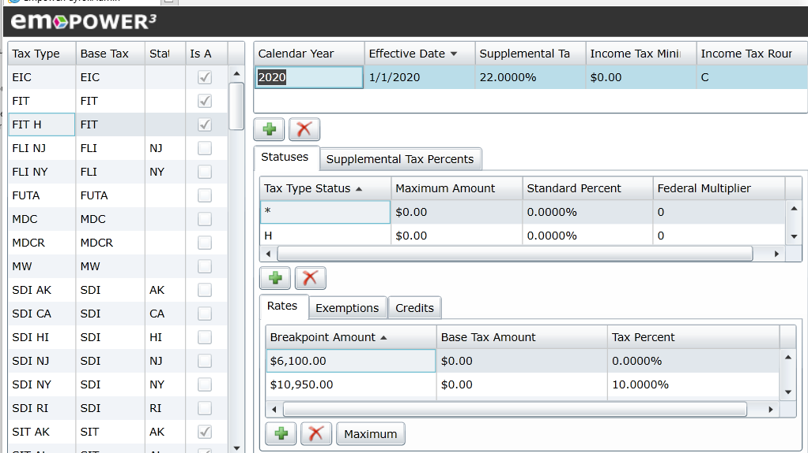

Public Class TaxTypeCalendarStatusModel
Public Property TaxType As String
Public Property CalendarYear As Int32
Public Property EffectiveDate As DateTime
Public Property TaxTypeStatus As String
Public Property StandardPercent As Decimal
Public Property MaximumAmount As Decimal
Public Property FederalMultiplier As Decimal
End Class
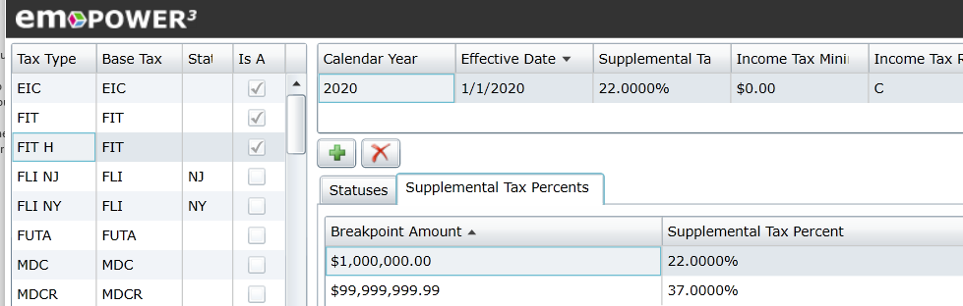

Public Class TaxTypeCalendarStatusCreditModel
Public Property TaxType As String
Public Property CalendarYear As Int32
Public Property EffectiveDate As DateTime
Public Property TaxTypeStatus As String
Public Property TaxExemptions As Int16
Public Property CreditAmount As Decimal
End Class

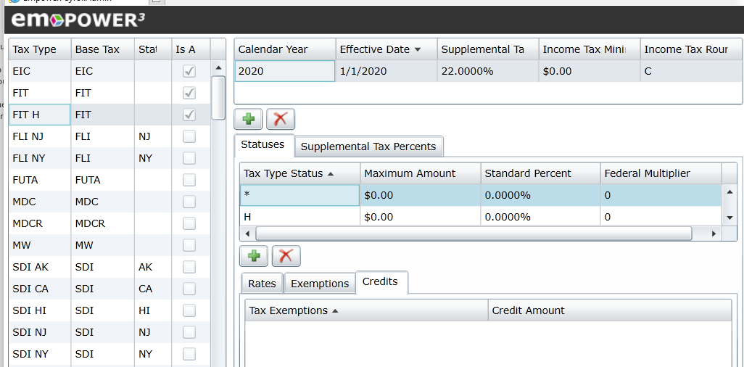

Public Class TaxTypeCalendarStatusExemptionModel
Public Property TaxType As String
Public Property CalendarYear As Int32
Public Property EffectiveDate As DateTime
Public Property TaxTypeStatus As String
Public Property TaxExemptions As Int16
Public Property ExemptionAmount As Decimal
End Class

Exemptions for Tax Type FIT H, Calendar Year 2020, Effective Date1/1/2020, Tax Type Status *

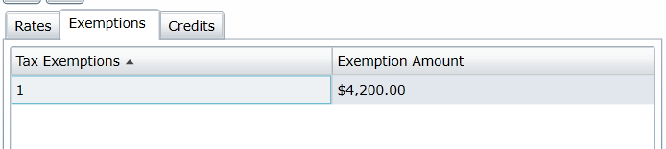

Public Class TaxTypeCalendarStatusRateModel
Public Property TaxType As String
Public Property CalendarYear As Int32
Public Property EffectiveDate As DateTime
Public Property TaxTypeStatus As String
Public Property BreakpointAmount As Decimal
Public Property BaseTaxAmount As Decimal
Public Property TaxPercent As Decimal
End Class

Rates for Tax Type FIT H, Calendar Year 2020, Effective Date1/1/2020, Tax Type Status *

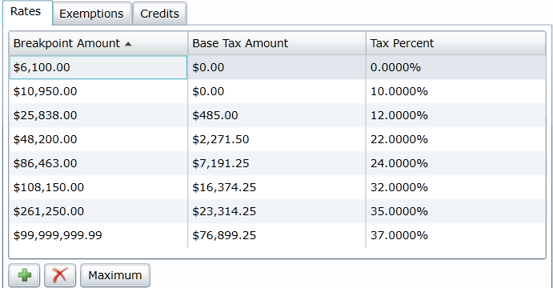

Exemptions for Tax Type FIT H, Calendar Year 2020, Effective Date1/1/2020, Tax Type Status M

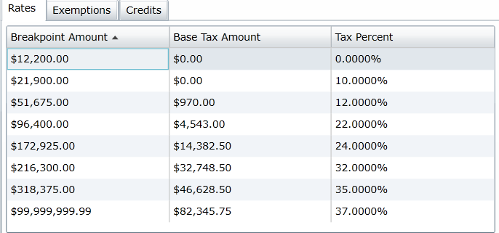

Protected Class IncomeTax
Public Property AnnualTax As Decimal
Public Property IncomeTax As Decimal
Public Property TaxCredit As Decimal
Public Property TaxableWages As Decimal
End Class

Protected Class TaxableWages
Public Property AnnualGrossWages As Decimal
Public Property StandardDeductionAmount As Decimal
Public Property ExemptionAmount As Decimal
Public Property FederalTaxDeductionAmount As Decimal
Public Property NoTaxes As Boolean
End Class

Protected Class YTDTax
Public Property BasisAmount As Decimal
Public Property Amount As Decimal
End Class

Protected Class MTDTax
Public Property BasisAmount As Decimal
Public Property Amount As Decimal
End Class

Comparing 10 to WIN

When Kathy says a state modification goes in uf_AnnualTaxableWages, that’s the equivalent of CalculateAnnualTaxableWagesStateExceptionsxx in SIT20nnCalculation in Win.

When Kathy says a state modification goes in uf_CalculateIncomeTax, that’s the equivalent of CalculateIncomeTaxExceptionsxx in SIT20nnCalculation.

